
A14
Sreenidhi Institute of Science & Technology
(An Autonomous Institution)
Code No: 4W102
M. TECH. I – Year I – Semester Examinations, March/April 2015, (Regular)
ADVANCED FINITE ELEMENT ANALYSIS (CAD/CAM)

Time: 3 Hours Max. Marks: 60

Note: No additional answer sheets will be provided.

Part - A
Max.Marks:10

Answer all QUESTIONS.
1. What is Finite difference method?
2. Define interpolation function.
3. Write the properties of Shape functions.
4. Define Plane strain condition.
5. Write the stiffness matrix for a frame element.
6. What are the thermal boundary conditions for composite wall?
7. Define Eigen value problem.
8. List some of the software packages available for finite element analysis.
9. Write the consistent mass matrix for a beam element.
10. Write the boundary conditions for fluid flow.
Part – B
Max. Marks: 50

ANSWER ANY FIVE QUESTIONS. EACH QUESTION CARRIES 10 MARKS.

1. Explain in detail about Jacobi and power methods used in finite element analysis.
2. For the two-bar truss shown in Figure 1, determine the displacements the point of application of load and also stress induced in the members. Assume Young’s Modulus as 200 GPa and Area of cross section as 200 mm².
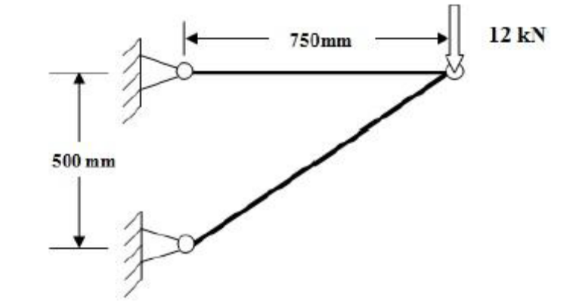
Figure 1
3. A beam of 10 m length is fixed at one end and supported by a roller at the other end has a 20 KN concentrated load applied at the centre of the span. Calculate the deflection under the load and construct the shear force and bending moment diagrams for the beam. Assume E = 2×10⁵ N/mm² and I = 2500cm⁴.

4. Derive the element Stiffness matrix for a 3 noded triangular element using the principle of minimum potential energy approach.

5. Determine the natural frequencies and mode shapes for the stepped bar shown in Figure 2. Take E = 70 GPa and specific weight 2700 kg/m³.
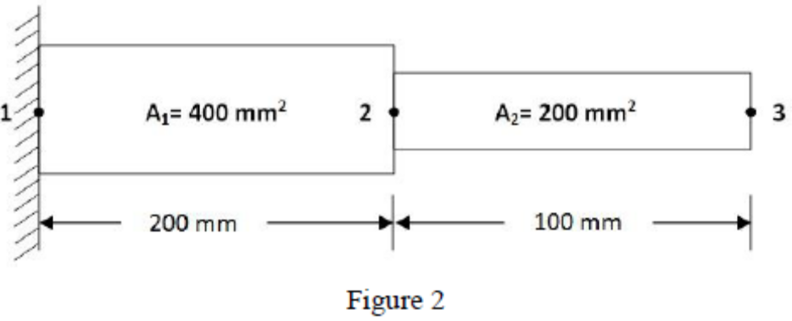
6. A composite wall consists of three materials shown in Figure 3. The outer temperature is 20⁰C. Convection heat transfer takes place on the inner surface of the wall with h = 20 W/m² ⁰C and T_{α} = 1000 ⁰C. Determine the temperature in the wall. Assume k₁ = 20 W/m ⁰C, k₂ = 30 W/m ⁰C and k₃ = 40 W/m ⁰C.
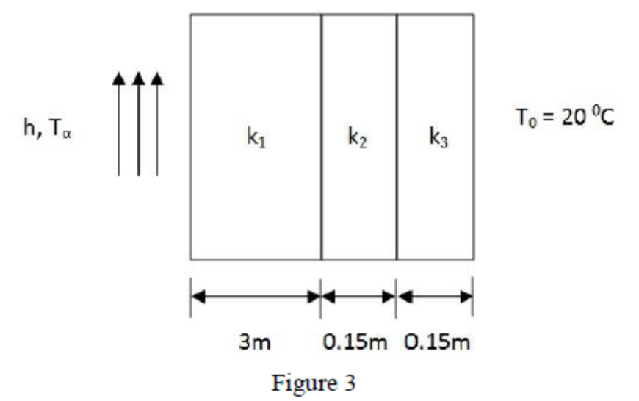

7. For the smooth pipe of variable cross section shown in Figure 4, determine the fluid heads at the junctions, the velocities in each pipe and the volumetric flow rate. The fluid head at the right end is 2 cm. The permeability coefficient is 2 cm/sec.
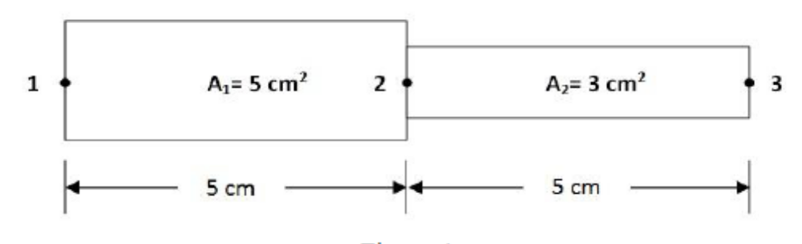
Figure 4

-- 00 -- 00 --

